Lab Guide

Retail Sales Aggregation by Market Segments

Watsonx.data

IBM Data and AI







Table of Contents

Background 7

Documentation 9

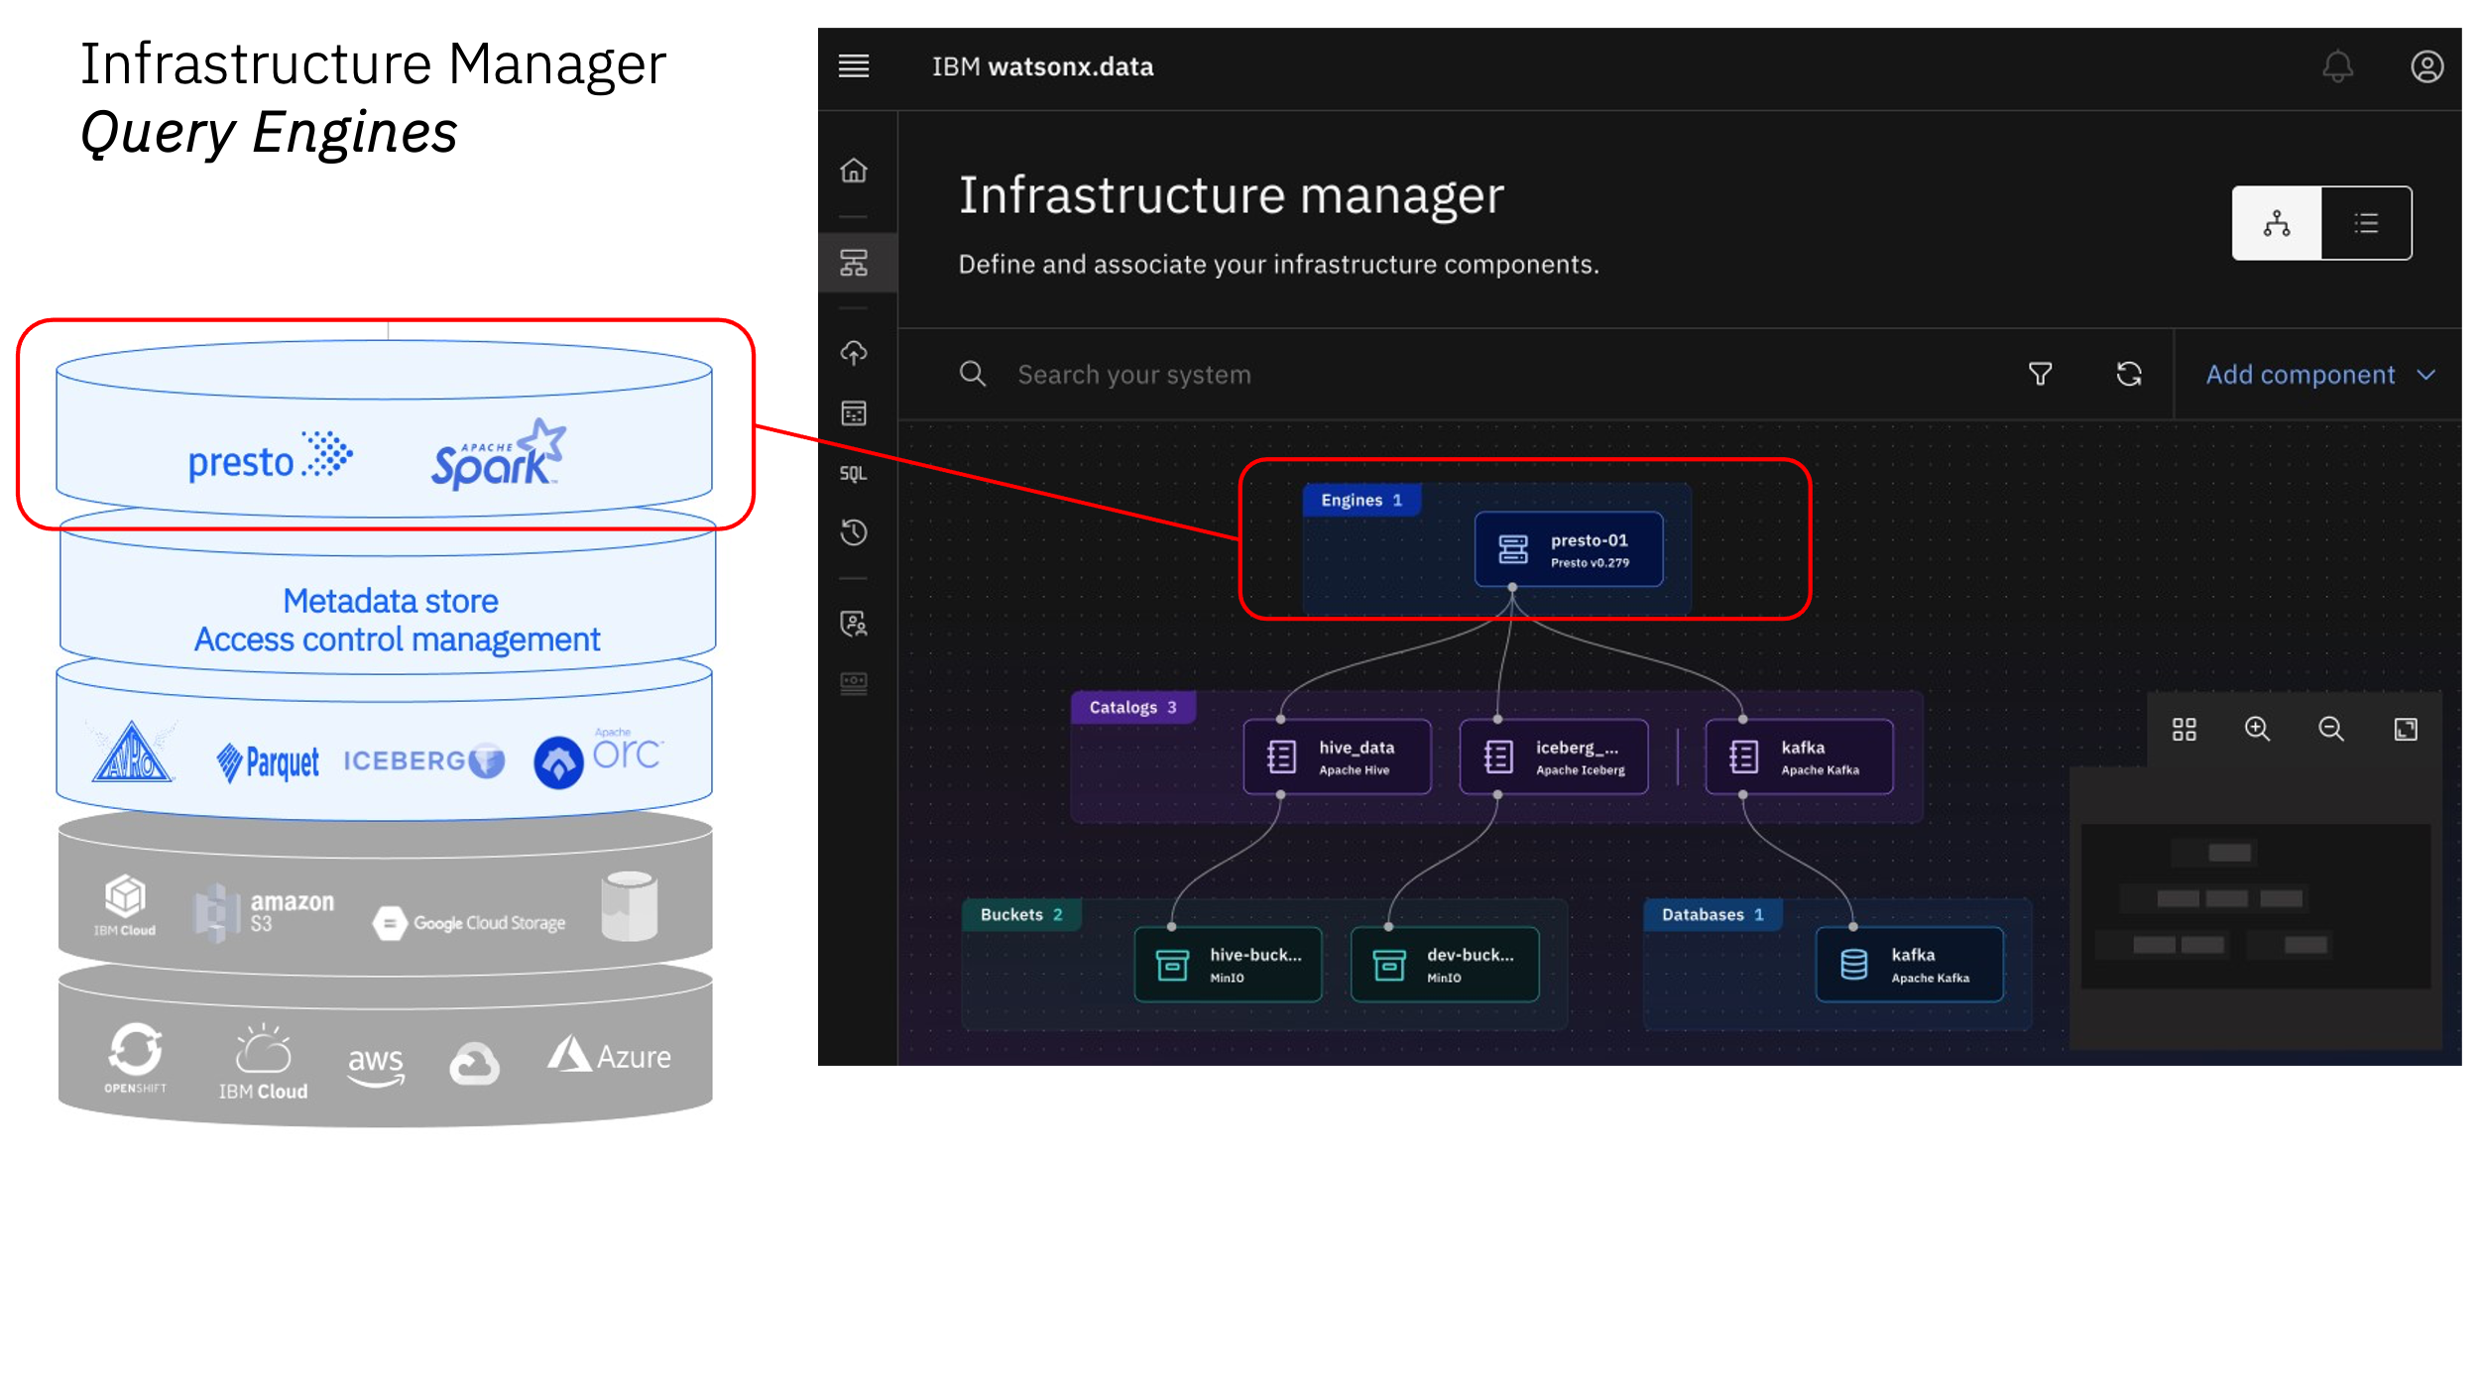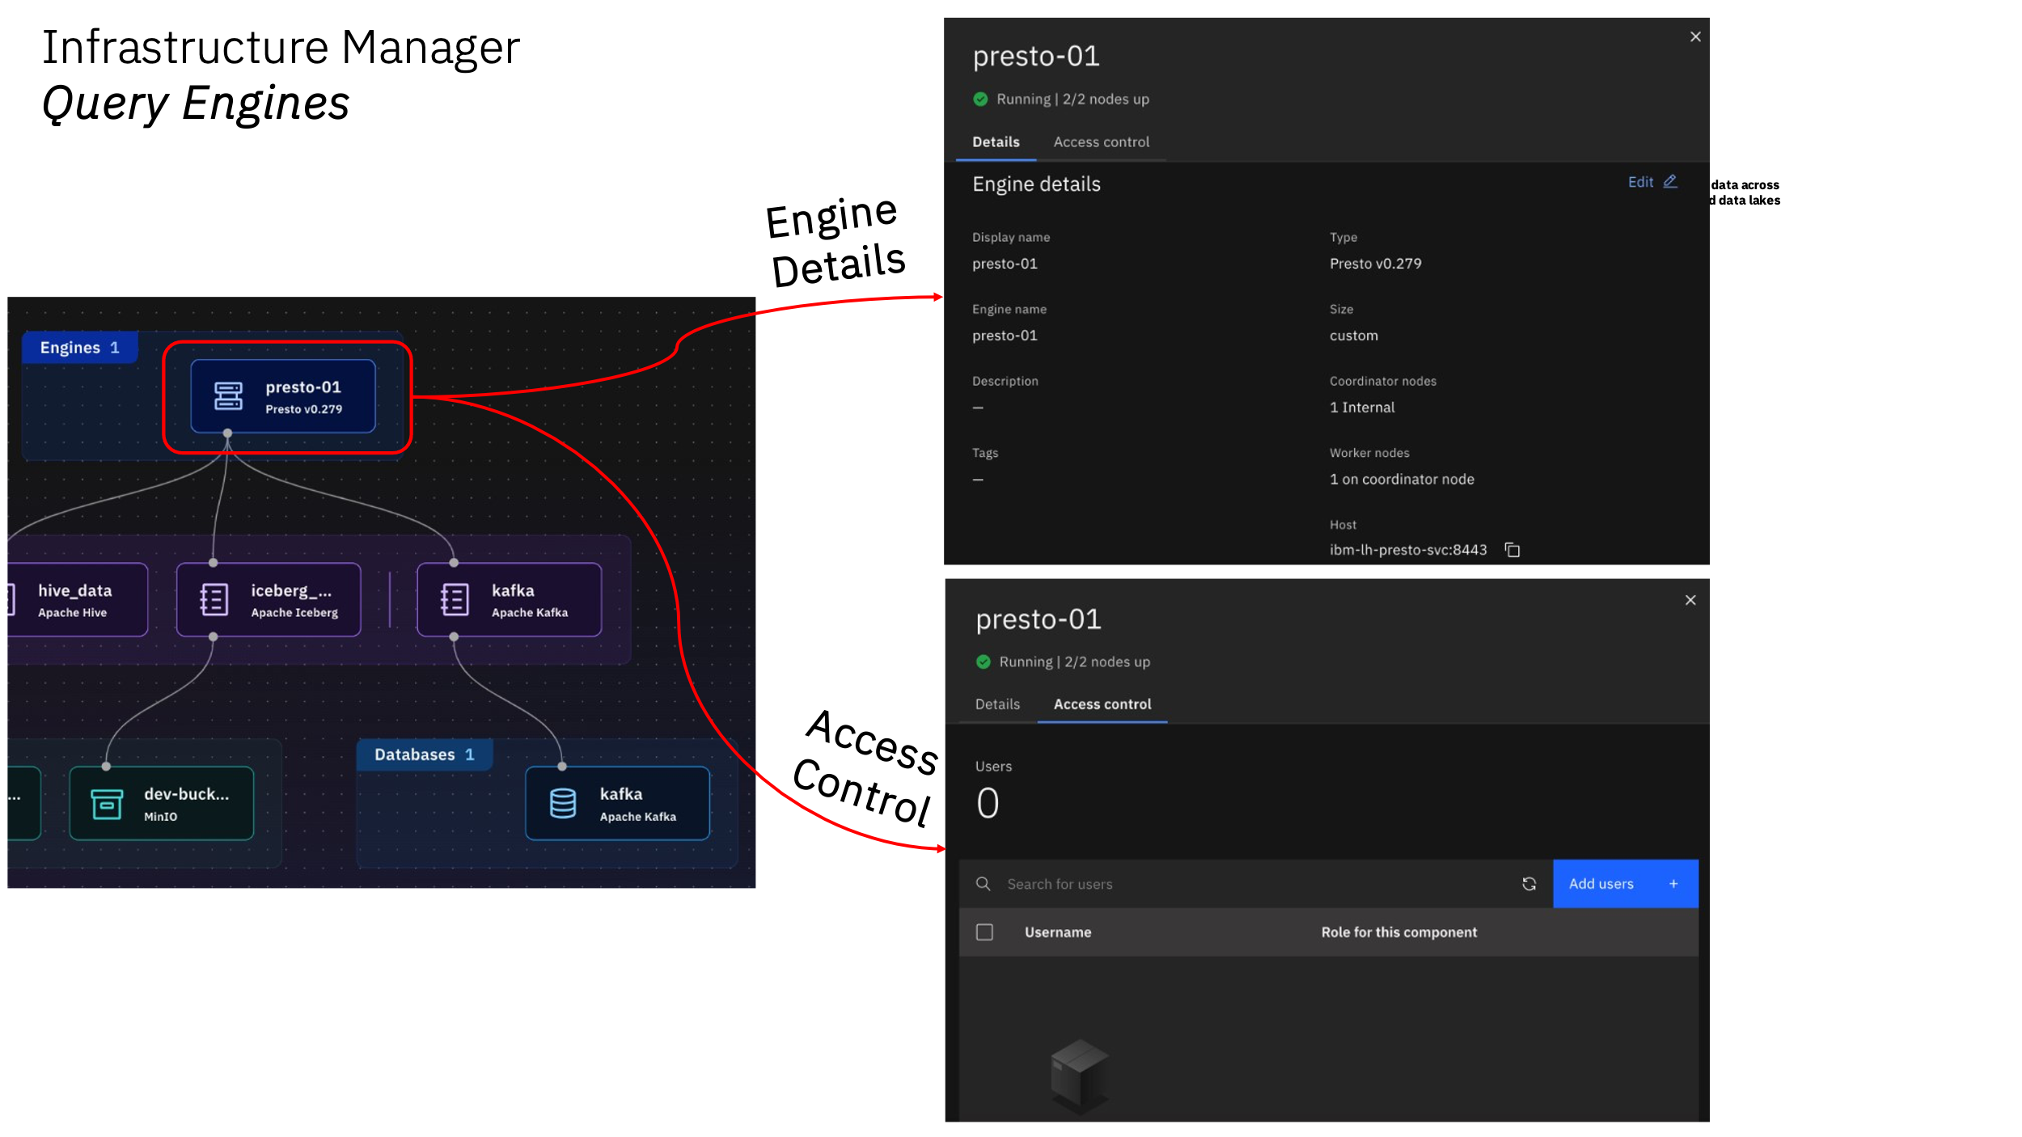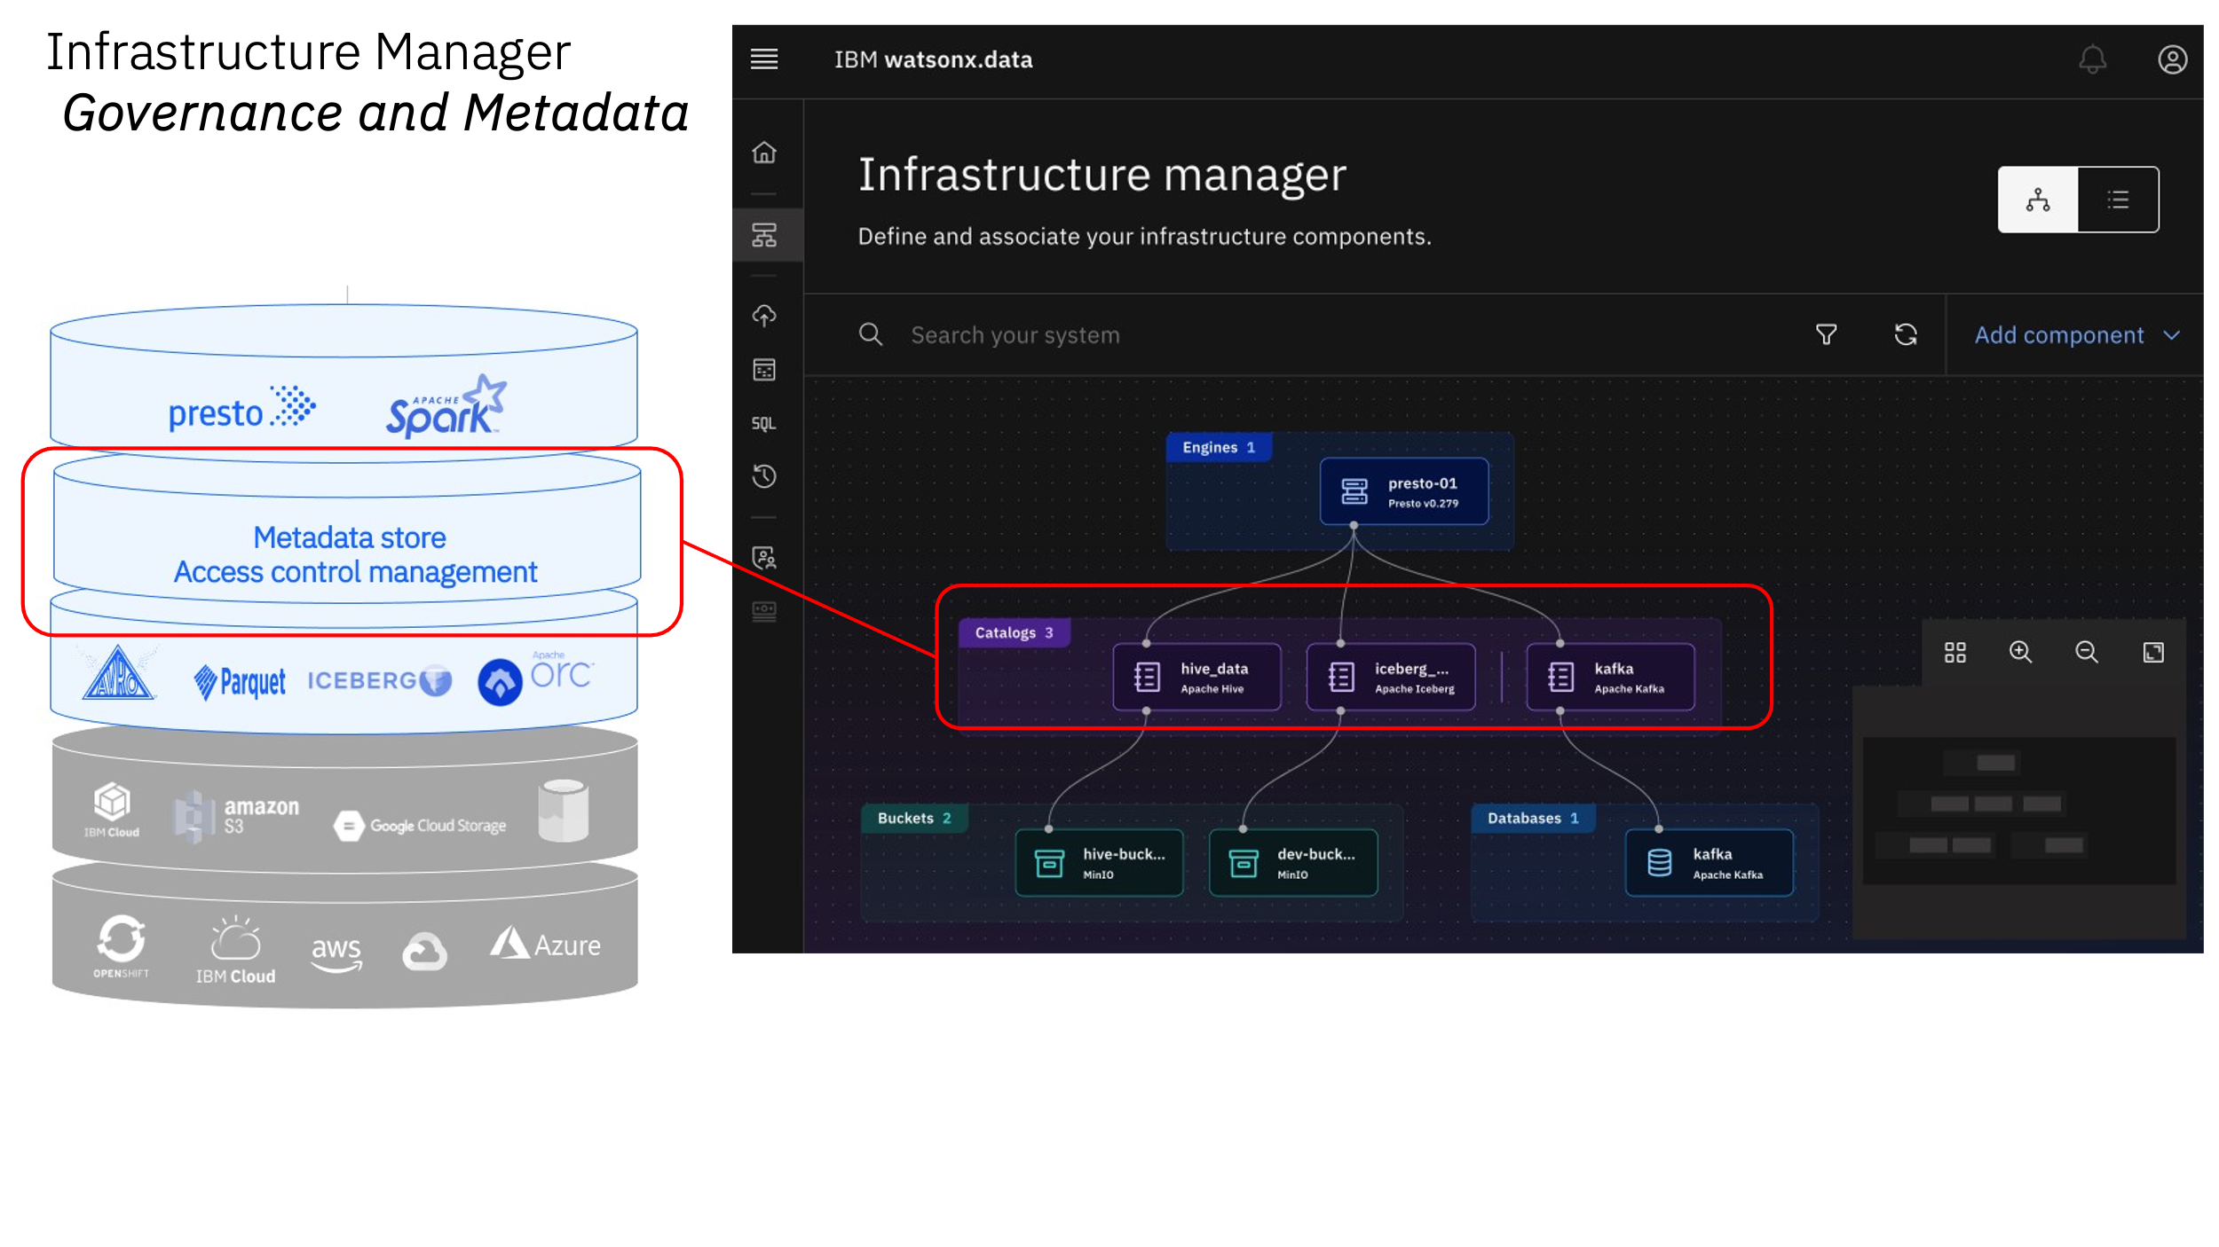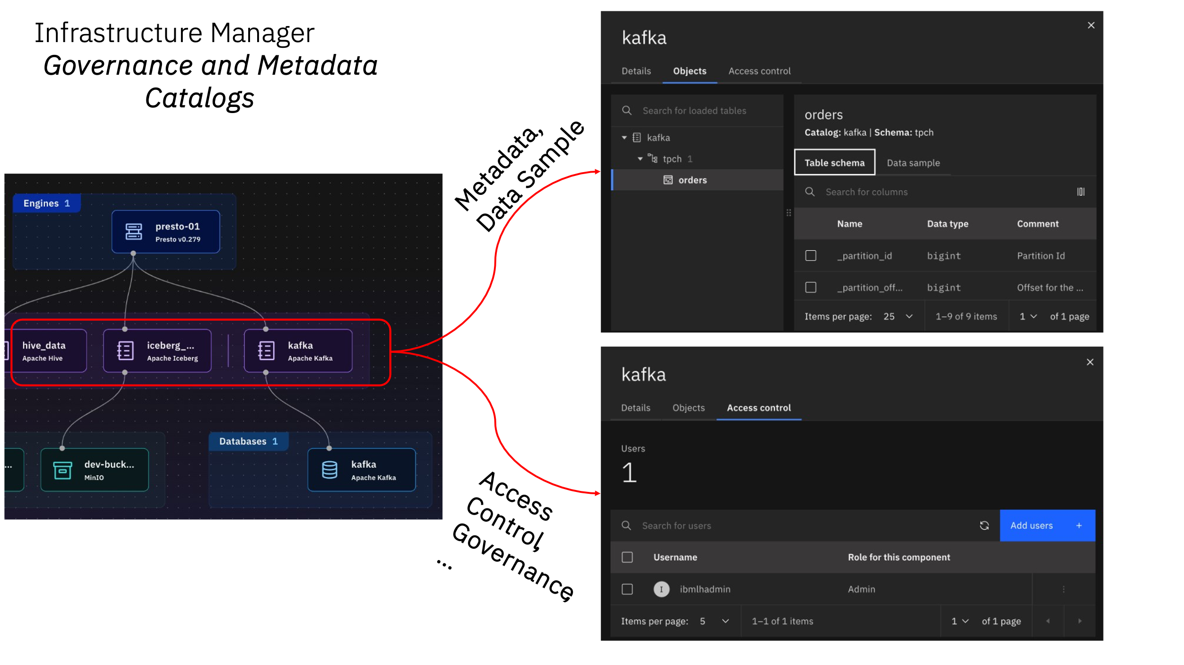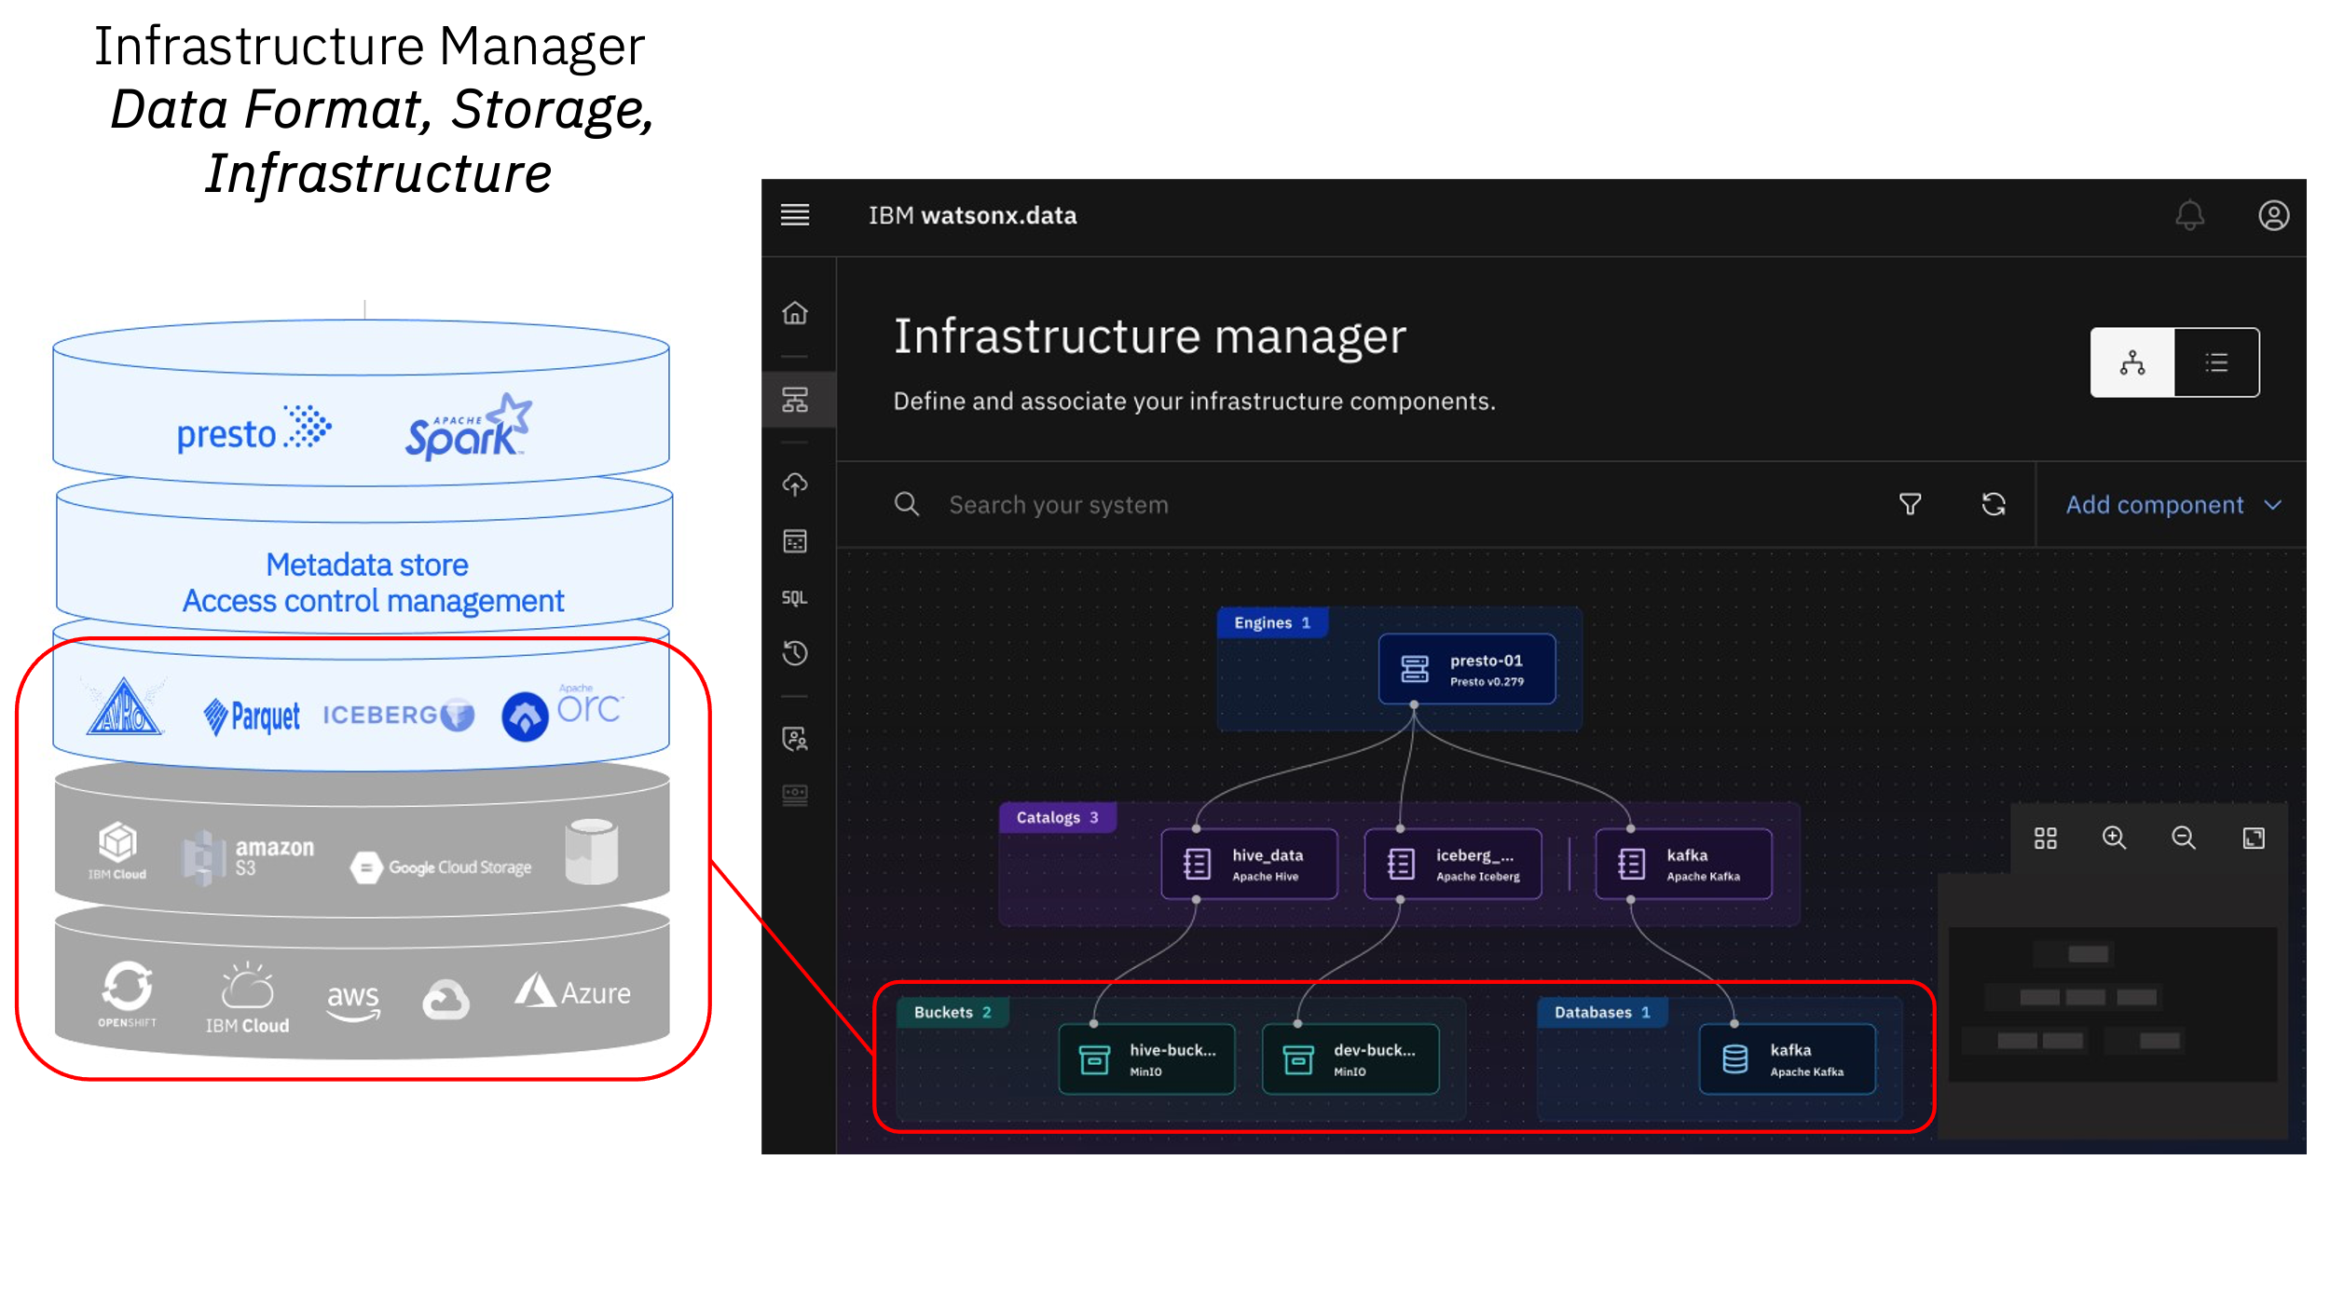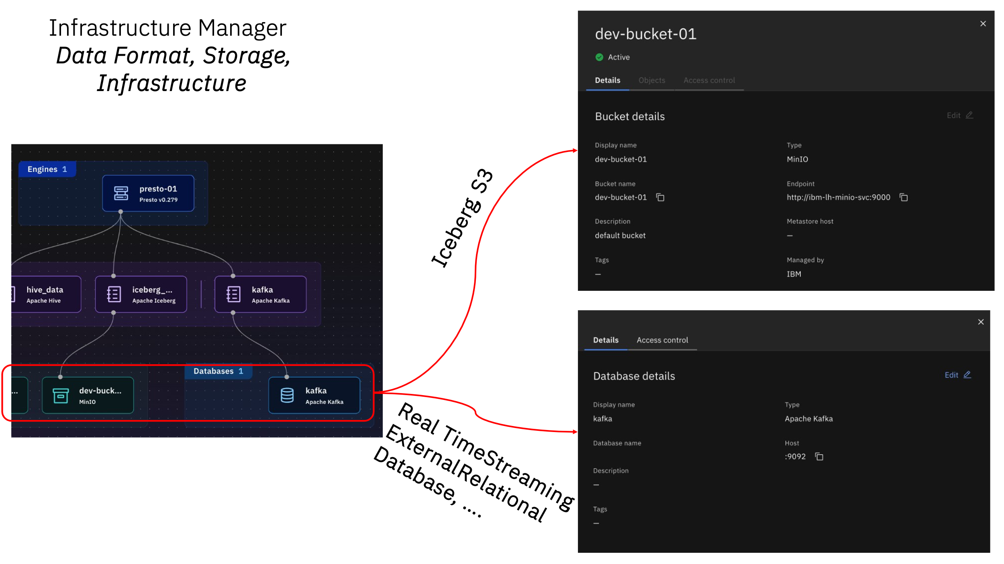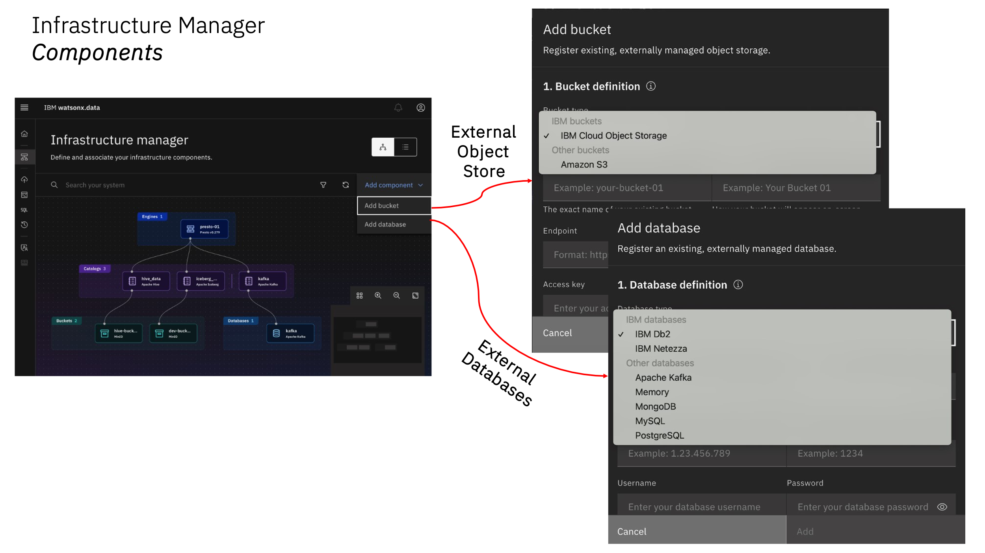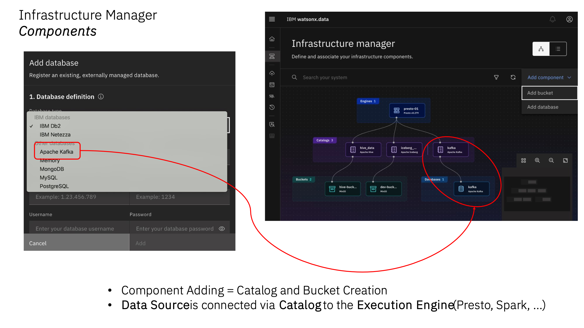 10

# Background

The next-gen watsonx.data lakehouse is designed to overcome the costs and complexities enterprises face. This will be the world’s first and only open data store with multi-engine support that is built for hybrid deployment across your entire ecosystem.

* WatsonX.data is the only lakehouse with multiple query engines allowing you to optimize costs and performance by pairing the right workload with the right engine.
* Run all workloads from a single pane of glass, eliminating trade-offs with convenience while still improving cost and performance.
* Deploy anywhere with full support for hybrid-cloud and multi cloud environments.
* Shared metadata across multiple engines eliminates the need to re-catalog, accelerating time to value while ensuring governance and eliminating costly implementation efforts.

This lab uses the watsonx.data developer package. The Developer package is meant to be used on single nodes. While it uses the same code base, there are some restrictions, especially on scale. In this lab, we will open some additional ports as well to understand how everything works. We will also use additional utilities to illustrate connectivity and what makes the watsonx.data system “open”.

We organized this lab into a number of sections that cover many of the highlights and key features of watsonx.data.

* Access a watsonx.data
* Starting watsonx.data
* Introduction to watsonx.data components
* Analytical SQL
* Advanced SQL functions
* Time Travel and Federation
* Working with Object Store Buckets

*At the end of each section, you will find the assets (scripts, csv files, etc.) needed to recreate steps in your own environment.

*Please note: This guide will be continuously updated as sample connections to additional technologies become available**.*

Additional resources

1. Watsonx.data development lab

<https://techzone.ibm.com/my/reservations/create/64dcc54d3a71eb3685d8da40>

1. IBM Watsonx.data beta version setup

<https://ibm.ent.box.com/file/1241740396395>

1. Environment Preparation lab guide for Python, Jupyter Notebook, Kafka, & Watsonx.data

https://ibm.ent.box.com/folder/223712533509

## Documentation

The following links provide more information on the components in this lab.

* watsonx.data

<https://www.ibm.com/docs/en/watsonxdata/1.0.x>

* Presto SQL

<https://prestodb.io/docs/current/sql.html>

* Presto Console

<https://prestodb.io/docs/current/admin/web-interface.html>

* MinIO

<https://min.io/docs/minio/linux/administration/minio-console.html>

* Apache Superset

<https://superset.apache.org/docs/creating-charts-dashboards/exploring-data>

* dBeaver

<https://dbeaver.com/docs/wiki/Application-Window-Overview/>

* Db2 SQL

<https://www.ibm.com/docs/en/db2/11.5?topic=queries-select-statement>

* PostgreSQL SQL

<https://www.postgresql.org/docs/current/sql.html>

## 

Pre-Requisites:

1. Python Server
2. Kafka Server
3. Jupyter Notebook
4. Watsonx.data server

Preliminary validation steps:

Step 1

Validate all the accesses configured by using the environment preparation document for python, Kafka, jupyter notebook and watsonx.data

Step 2

Open the URL of watsonx.data specify your server address if any

<https://169.60.148.131:9443/#/home>

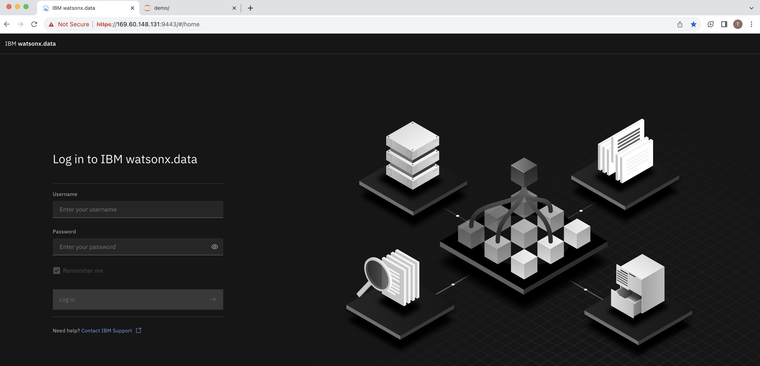

Use Credential to login

User Name : ibmlhadmin. Password: password

Step 3.

Login using the credentials mentioned above ; on successful validation of credential you will land to the below home page

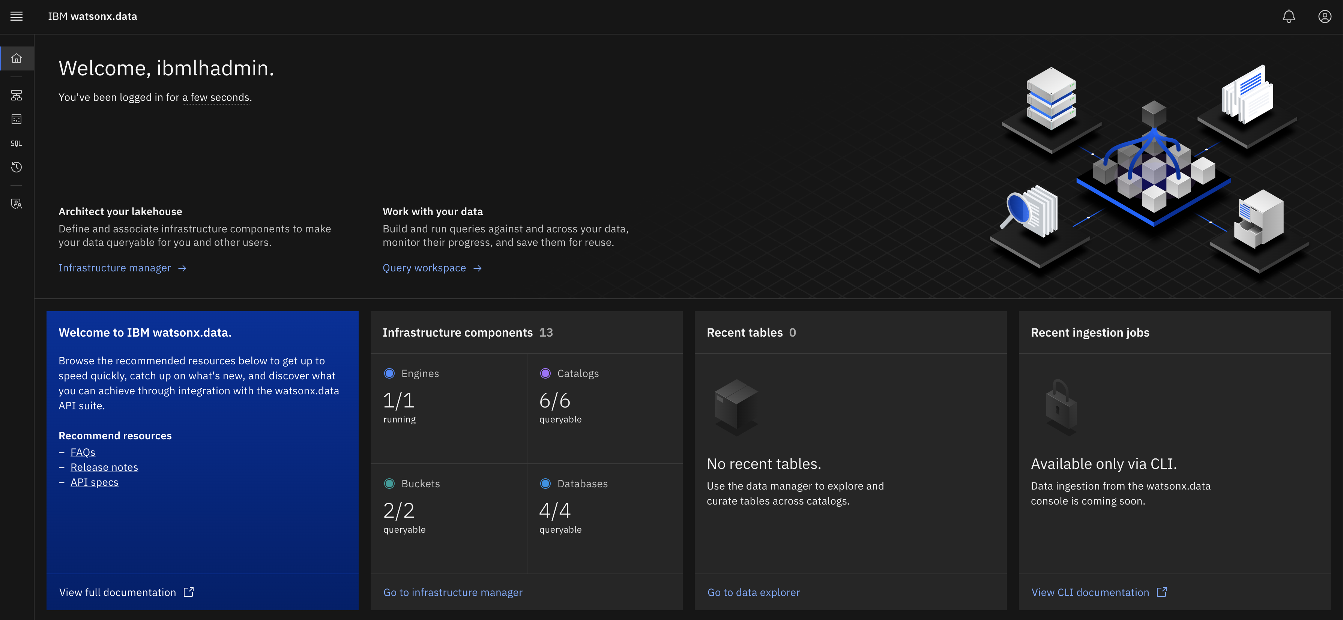

Step 4.

Click on infrastructure manager to see all the added Catalogs with buckets and databases

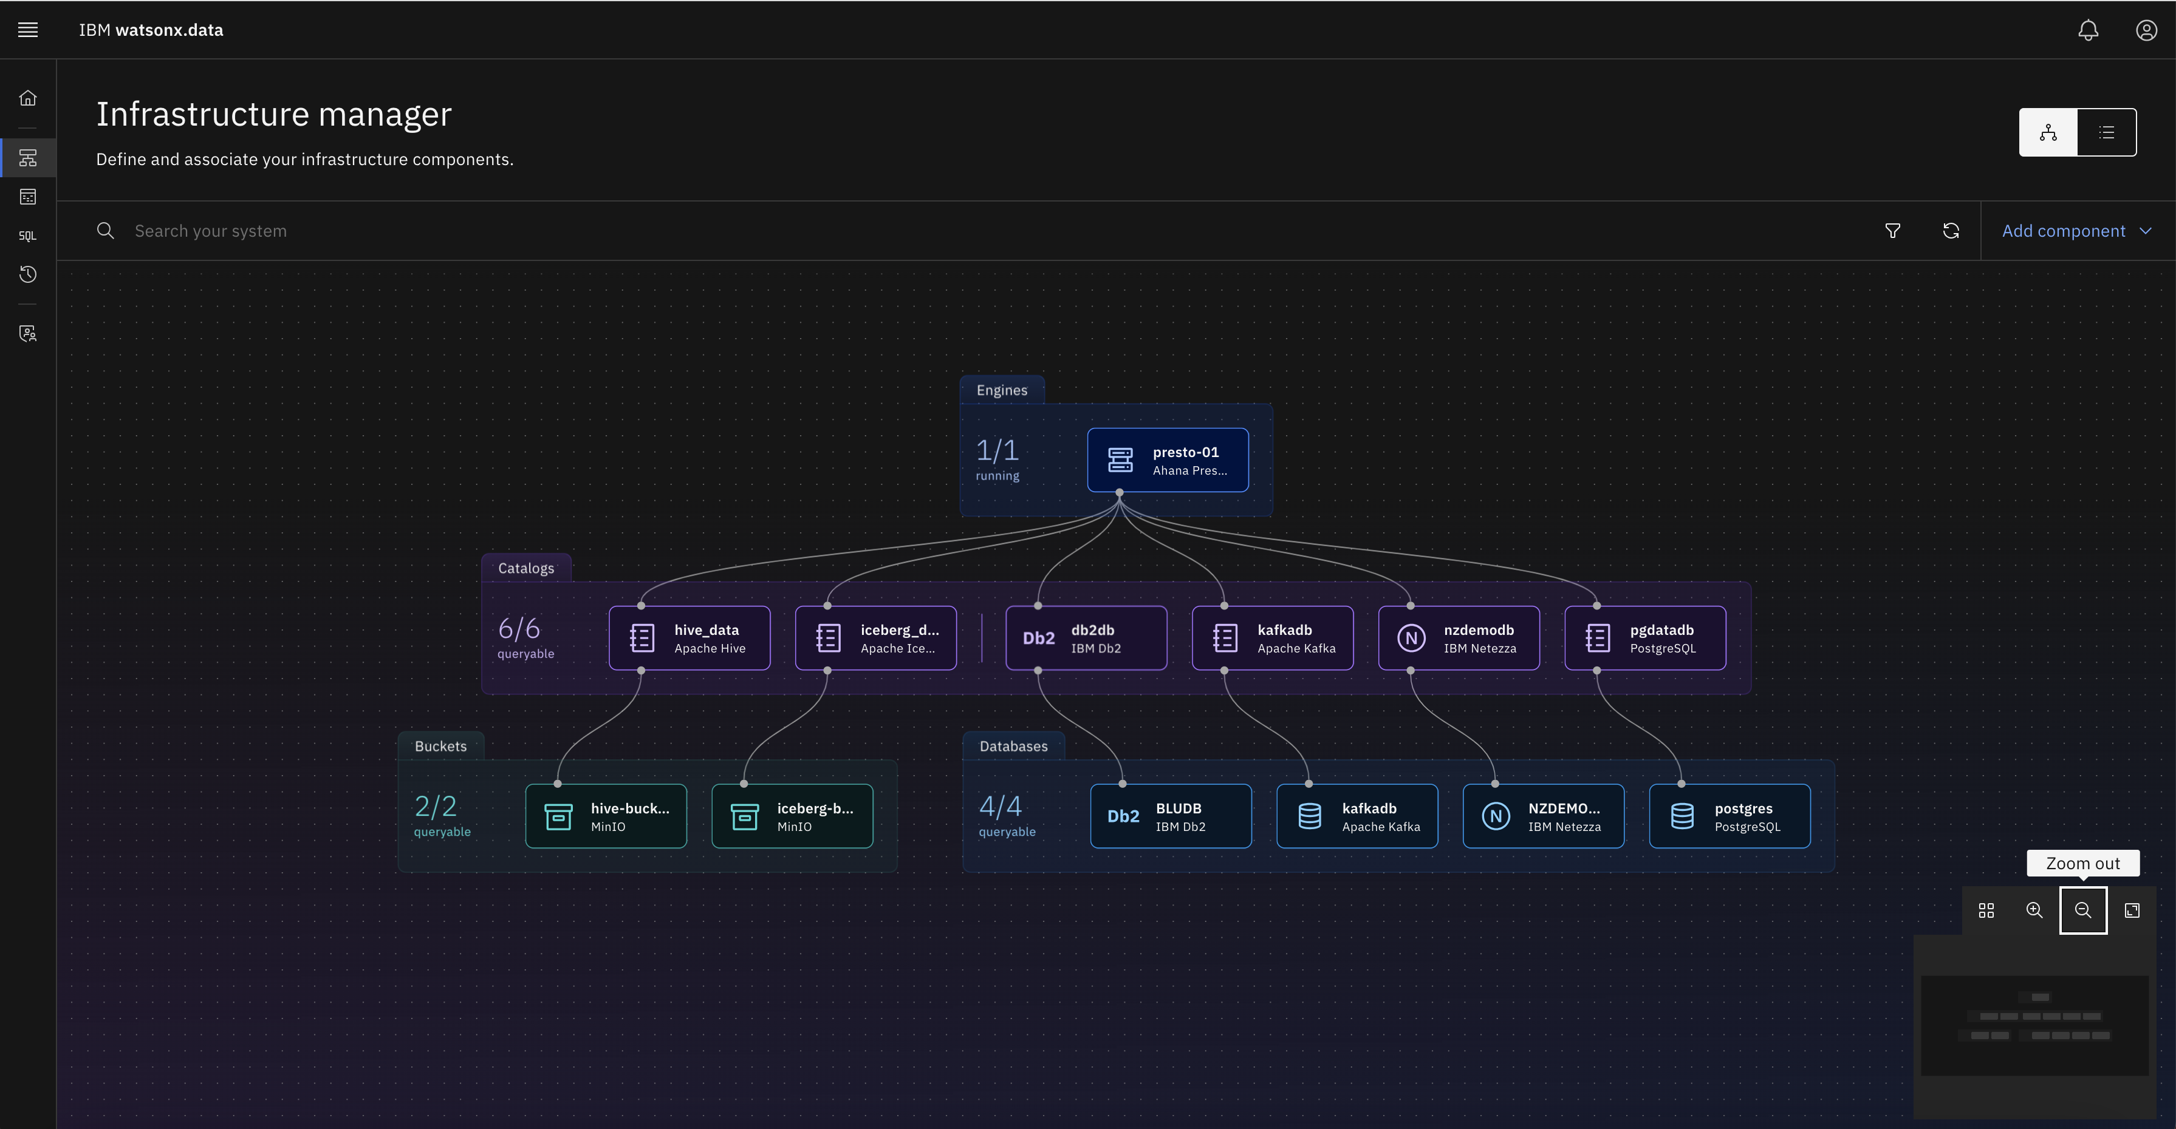

Step 5.

When you click on the Add component then you can add bucket or database connection to watsonx.data to federate the data

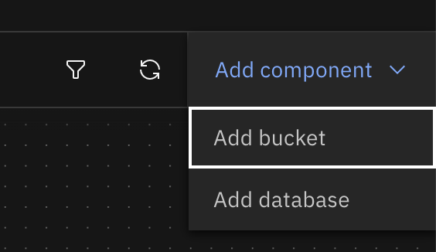

Step 6.

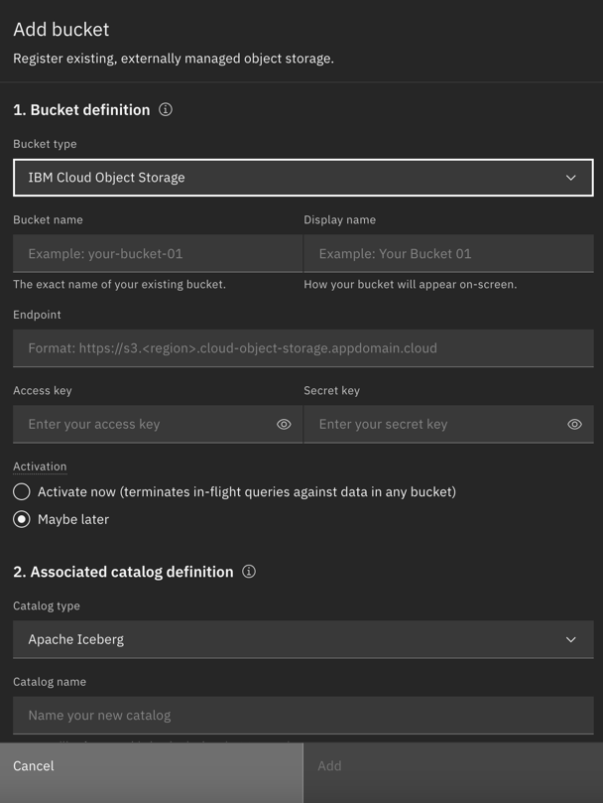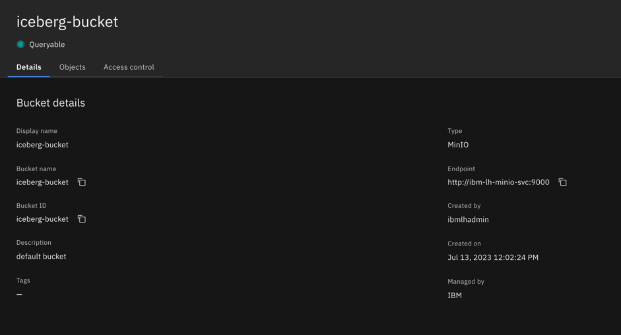Details related to buckets

In our case the iceberg details are shown in the right side window.

Step 7.

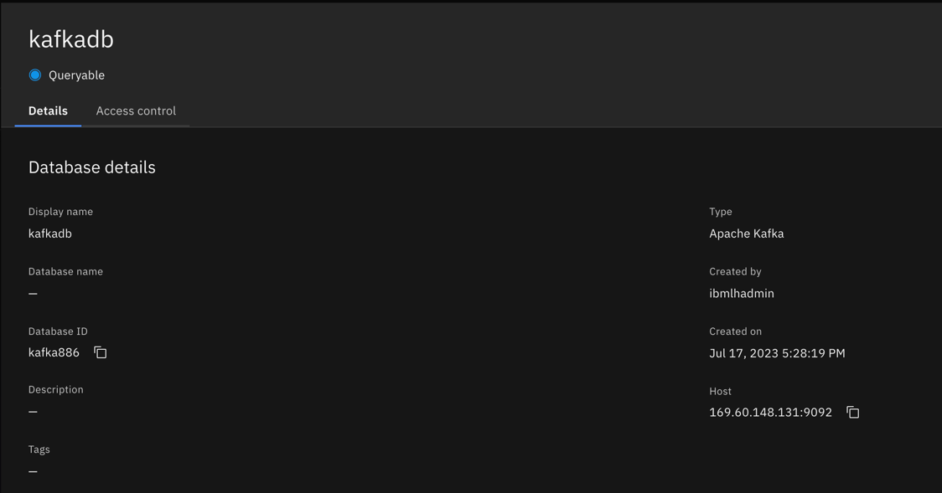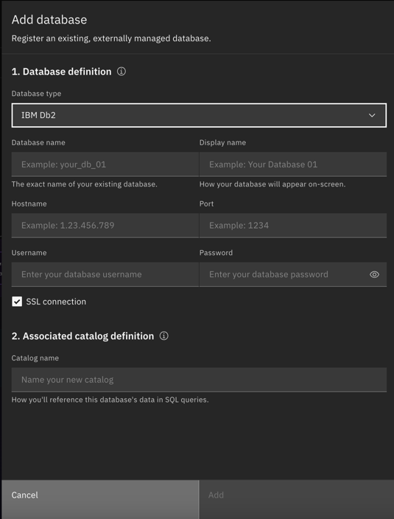Details related to Database:

In our case the database details are available in right side window.

Load data in kafka topic:

Execute script to load the data in tpch.orders

./gen_data orders.tpl tpch.orders



Step 8.

Use the URL generated by jupyter notebook server to interact with watsonx.data (use your server ip address)

<http://169.60.148.131:8888/?token=4e4255c4e2389f57d5898ba35e713538fb213456082bfefb>

Step 9:

Open the python notebook file to execute on the watsonx.data box

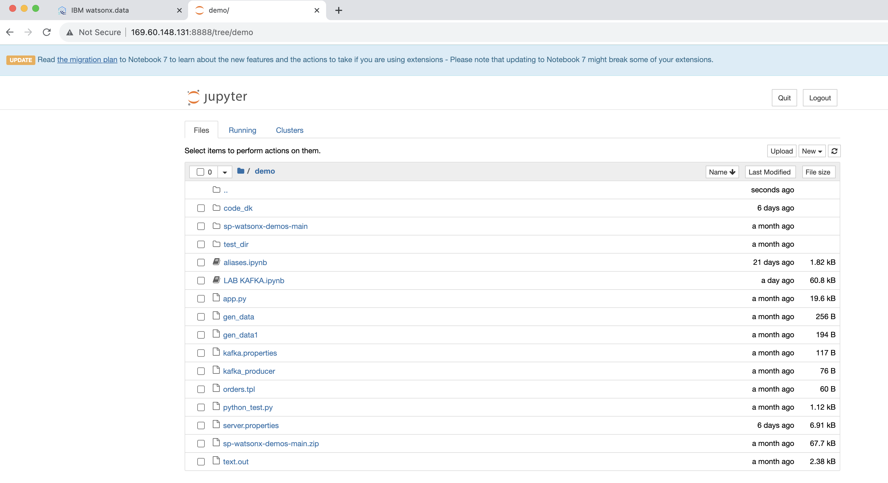

Step 10:

Now you are ready to query the watsonx.data using Query workspace available on watsonx.data as well as using python notebook

1. Here we would like to read the messages loaded in kafka topics by using gen_data script

SQL Query:

SELECT _message FROM "kafkadb"."tpch"."orders" LIMIT 10;

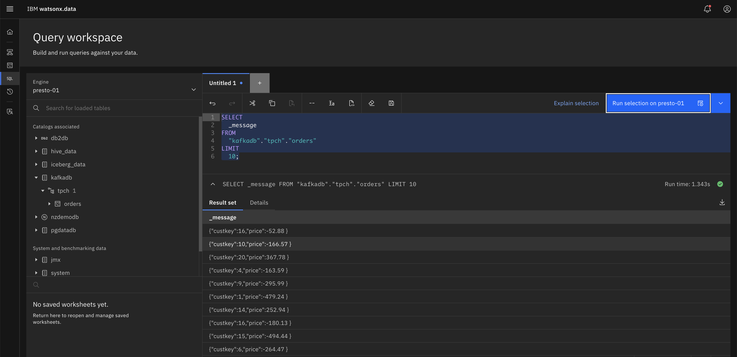

1. Here we would like to query the table customer from workshop schema and iceberg data datasets

SQL Query:

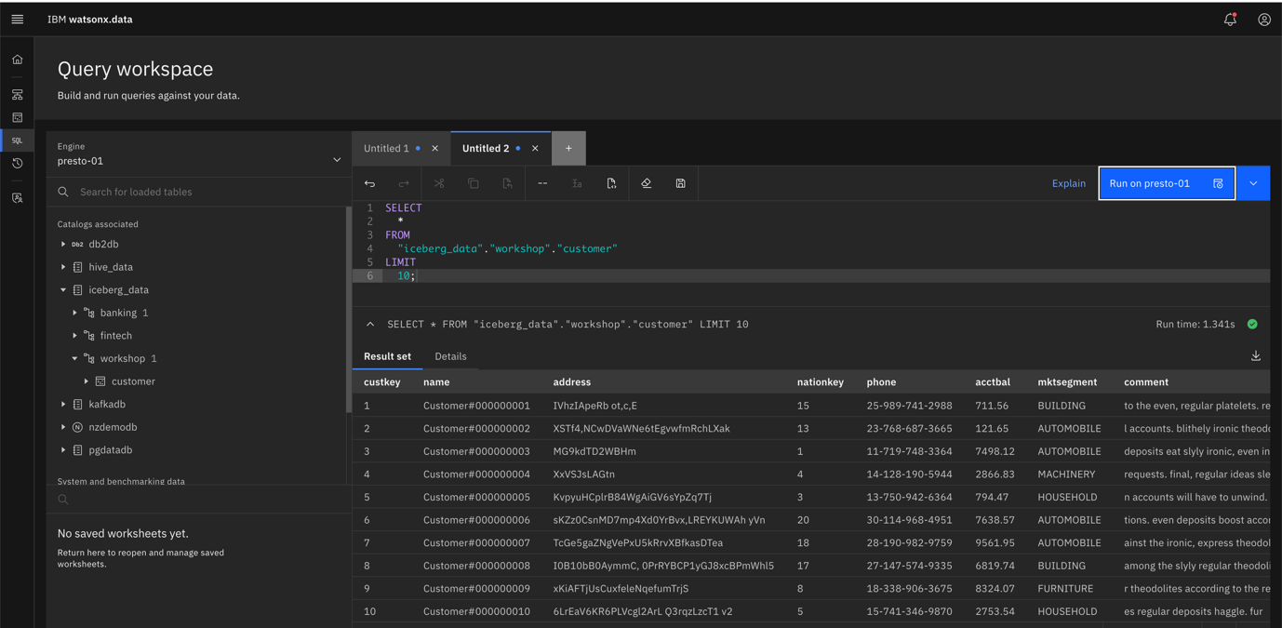SELECT * FROM "iceberg_data"."workshop"."customer" LIMIT 10;

1. Now we would like to federate the records by using these two heterogeneous source systems one is streaming engine kafka and other is iceberg datasets

SQL Query:

with

t1 as (

SELECT cast(json_extract(_message,'$.custkey') as int) custkey,

cast(json_extract(_message,'$.price') as real) price

FROM kafkadb.tpch.orders),

t2 as (

SELECT * FROM iceberg_data.workshop.customer

)

SELECT t2.mktsegment,avg(t1.price) as avg_price

FROM t1 JOIN t2

ON t1.custkey=t2.custkey

GROUP BY 1 ORDER BY 1

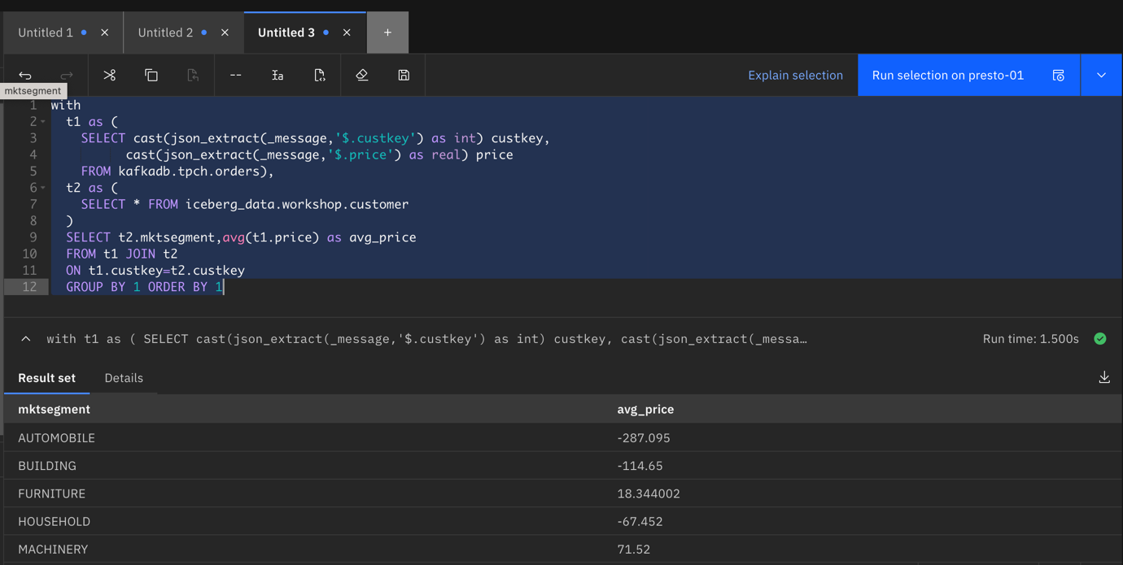

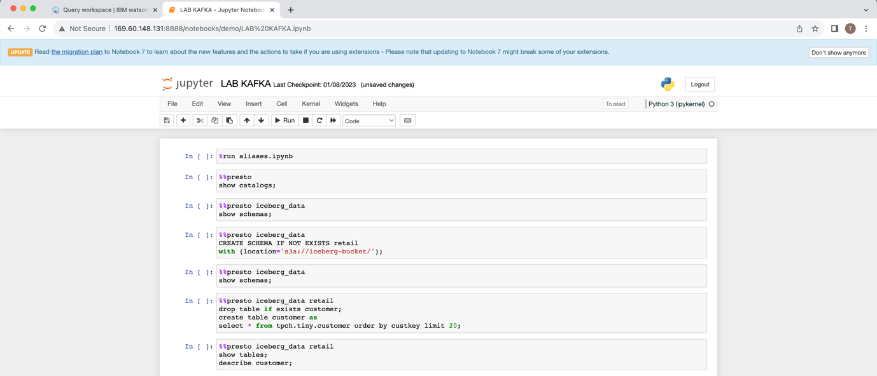Now we are good with the SQL Query execution on watsonx.data platform using presto engine on heterogeneous sources.

Another Approach we can see by using Python notebook.

Step 11:

Open the URL of python notebook

<http://169.60.148.131:8888/notebooks/demo/LAB%20KAFKA.ipynb>

Run commands one by one and get the output on the same screen

Step 12:

In image you can see the python code to plot graph for the sales aggregation based on market segment.

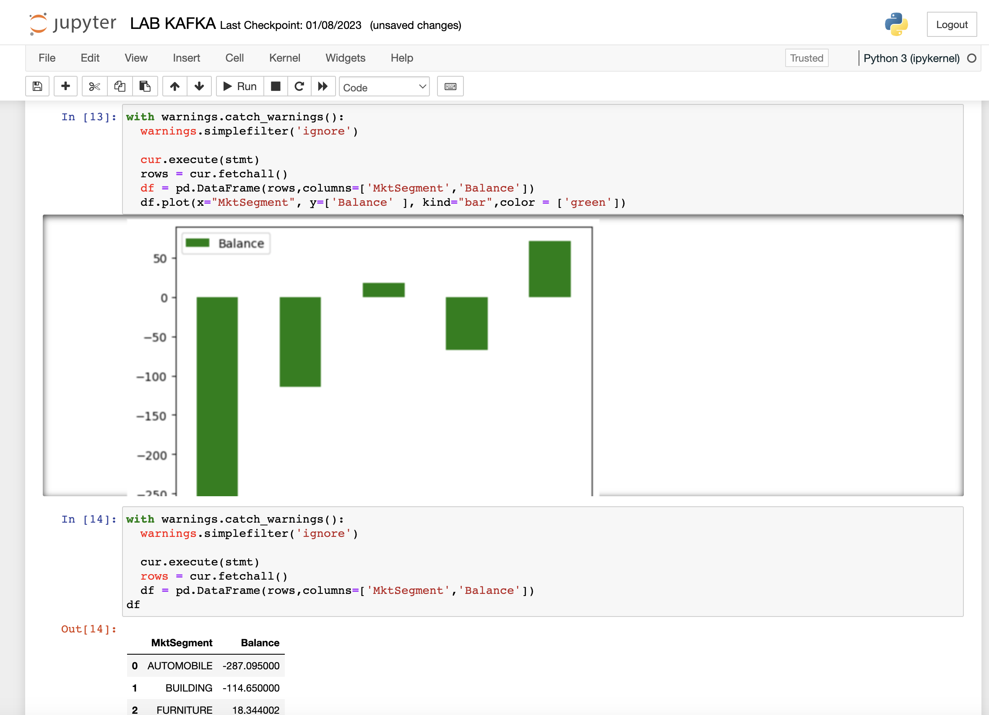

Step 13:

Time Travel in Watsonx.data :

By using snapshot id you can rollback the data to specific snapshot created/committed on.

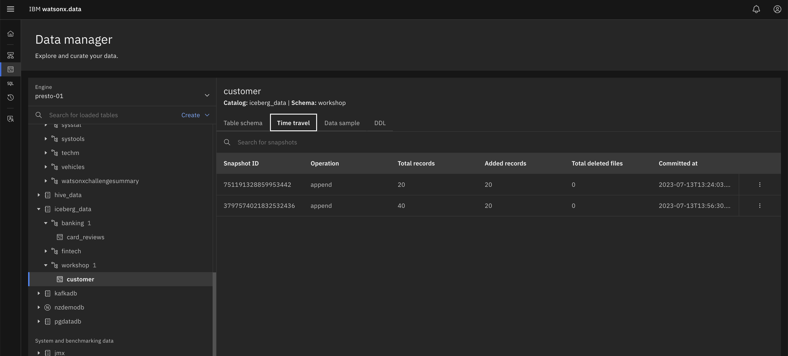

**Conclusion**

In this lab, you've learned how to connect to Watsonx.data using the Presto CLI and executed queries to explore available catalogs, schemas, tables, functions, and gather statistics. This knowledge will help you navigate and utilize Watsonx.data effectively for your data exploration needs.